**Full Stack Development with MERN**

**Frontend Development Report**

|  |  |
| --- | --- |
| Date | 10-07-24 |
| Team ID | SWTID1719938064 |
| Project Name | ShopEZ: E-Commerce Application |
| Maximum Marks | 10 |

**Project Title: ShopEZ: E-Commerce Application**

Date: 10-07-24

Prepared by:MOKSHAGNA & TEAM

**Objective**

The objective of this report is to document the frontend development progress and key aspects of the user interface implementation for the ShopEZ: E-Commerce Application project.

**Technologies Used**

* **Frontend Framework:** React.js
* **State Management:** non used
* **UI Framework/Libraries:** Bootstrap
* **API Libraries:** Axios

**Project Structure**

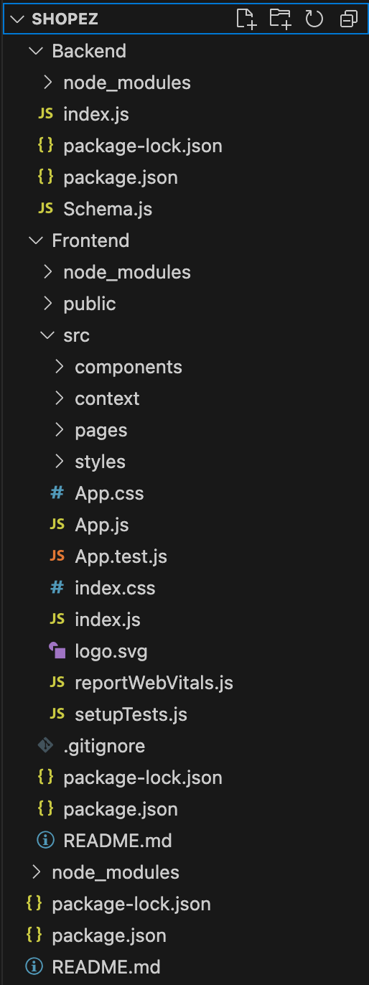

**Key Components**

1. **App.js**
   * Responsible for routing and main application layout.
2. **/components**
   * Contains reusable UI components used across the application.
3. **/pages**
   * Includes different pages for Web App.
4. **/styles**
   * Includes all component’s css files.

**Routing**

Routing is managed using React Router. Here are the main routes:

* **/home** - Landing page of the application.
* **/profile** - User profile management.
* **/cart - P**roducts which are in cart
* **/product- A**ll the details of product
* **/auth- L**ogin page
* **/category-** To match category of products.

**State Management**

Non used

**Integration with Backend**

The frontend communicates with the backend APIs hosted on http://localhost:6001/

. Key endpoints include:

* **GET /api/data** - Retrieves data for display.
* **POST /api/user/login** - Handles user authentication.

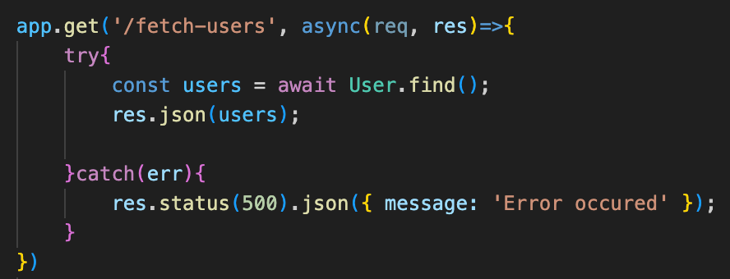

**User Interface (UI) Design**

* The UI design follows a navy blue and white theme which give user a bold feeling and containes designs which are user interactive.
* Implemented using bootstap and css.

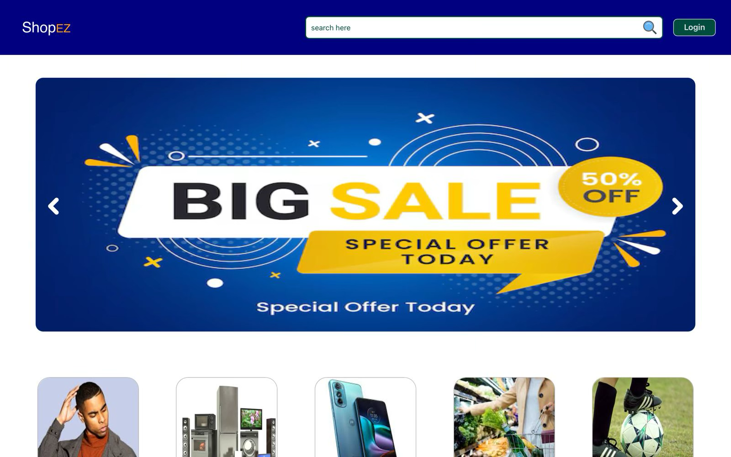

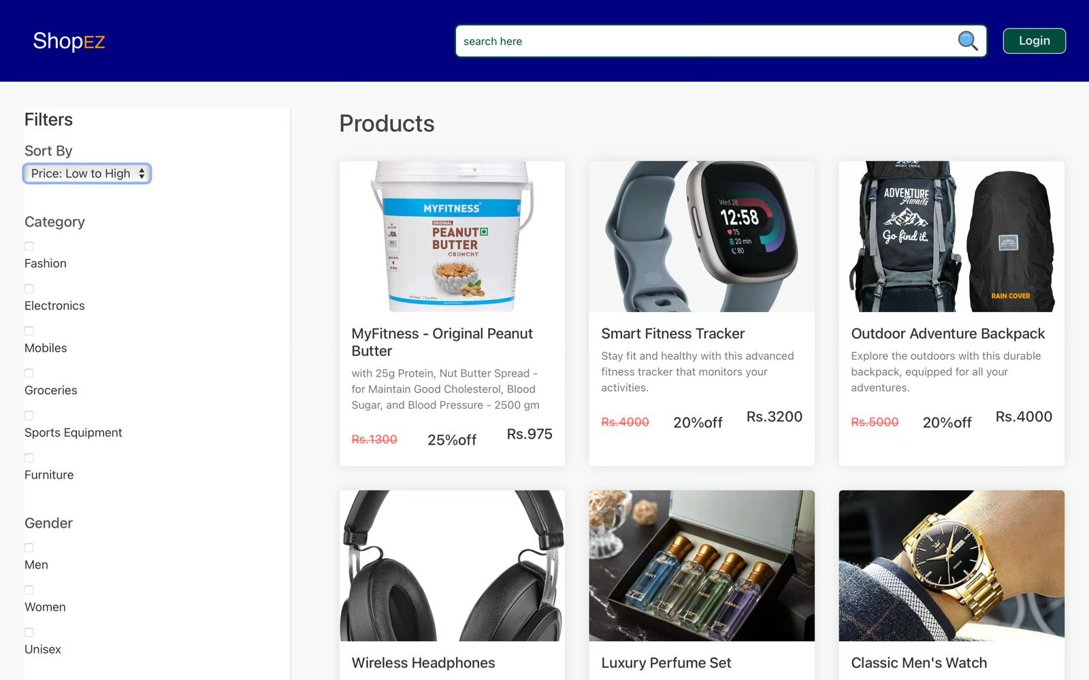

**Third-Party Integrations (If any)**

none